1. Given the following equation: 8 Fe + S₈ ---> 8 FeS
What mass of iron is needed to react with 16.0 grams of sulfur?
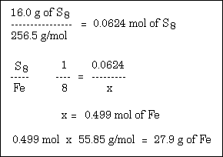
How many grams of FeS are produced?
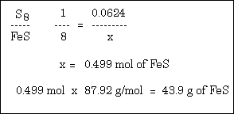
2. Given the following equation: 2 NaClO₃ ---> 2 NaCl + 3 O₂
12.00 moles of NaClO₃ will produce how many grams of O₂?
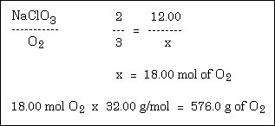
How many grams of NaCl are produced when 80.0 grams of O₂ are produced?
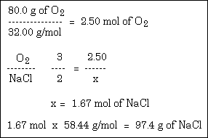
3. Given the following equation: Cu + 2 AgNO₃ ---> Cu(NO₃)₂ + 2 Ag
How many moles of Cu are needed to react with 3.50 moles of AgNO₃?
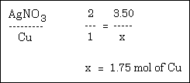
If 89.5 grams of Ag were produced, how many grams of Cu reacted?
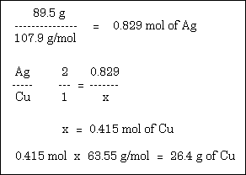
4. Molten iron and carbon monoxide are produced in a blast furnace by the reaction of iron(III) oxide and coke (pure carbon). If 25.0 kilograms of pure Fe₂O₃ is used, how many kilograms of iron can be produced? The reaction is: Fe₂O₃ + 3 C ---> 2 Fe + 3 CO
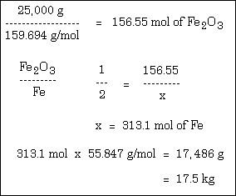
5. The average human requires 120.0 grams of glucose (C₆H₁₂O₆) per day. How many grams of CO₂ (in the photosynthesis reaction) are required for this amount of glucose? The photosynthetic reaction is: 6 CO₂ + 6 H₂O ---> C₆H₁₂O₆ + 6 O₂
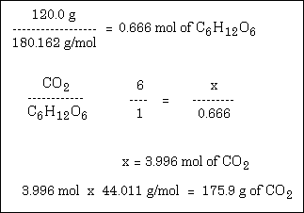
6. How many grams of Ca(OH)₂ are needed to make 100.0 mL of 0.250 M solution?
.250 moles/liter x 100 mL x 1L/1000mL x 74 g/mole=1.85 grams
7. What is the molarity of a solution made by dissolving 20.0 g of H₃PO₄ in 50.0 mL of solution?
20g H₃PO₄ /50 mL x 1000mL/L x 1 mole H₃PO₄ / 94 g H₃PO₄ = 4.25 M H₃PO₄
8. What weight (in grams) of KCl is there in 2.50 liters of 0.500 M KCl solution?
.5 moles KCl/L x 2.5 L x 74.6 g KCl/ 1 mole KCl= 93.25 g KCl
9. What is the molarity of a solution containing 12.0 g of NaOH in 250.0 mL of solution?
12 g NaOH/ 250 mL x 1000 mL/L x 1 mole NaOH/40 g NaOH= 1.2 M NaOH

